CHEMISTRY UNIT 3 & 4
Test #4:
Organic Chemistry
NAME: |  |  | ANSWERS
Time allowed for this paper
Reading time: |  | 5 minutes
Working time: |  | 50 minutes
Structure of this paper:
Section |  |  | Number of questions | Marks available |  | Marks achieved
Section One:  Multiple Choice |  |  | 10 | 10
Section Two:  Short Answer |  |  | 6 | 41
 |  |  |  |  | Total | ______ / 51

Section One: Multiple Choice

- Which of the following molecules can exhibit geometric (cis-trans) isomerism?

- CH₃-CH₂-CH=CH-CH₃
- CH₂=CH-CH₂Br
- CH₂BrCH₂Br
- CH₃CH=C(CH₃)₂

- A student was given the task of identifying a liquid organic compound that contains only carbon, hydrogen and oxygen. The following tests were carried out:

 | Procedure | Result
Test 1 | Some brown Br₂(aq) was added to a sample of the compound | A reaction occurred and a colourless product formed
Test 2 | Some Na₂CO₃(s) was added to a sample of the compound | A reaction occurred and a colourless gas was evolved.

Which structure below matches all the provided observations?

- Which of the following is least soluble in water?

- CH₃CH₂OH
- CH₃CH₂CH₂CH₂CH₂CH₂OH
- CH₃COCH₃
- HOCH₂CH(OH)CH₂OH

- The systematic or IUPAC name for the following is
- 2-bromo-2-methylbutanoic acid.
- 2-ethyl-2-bromopropanoic acid.
- 3-bromo-3-methylbutanoic acid.
- cis-3-propanoic acid

- The ester present in artificial strawberry flavouring is shown below.

The two compounds which were used to chemically prepare this ester were:
- butanol and ethanoic acid.
- ethanol and butanoic acid.
- hexanol and acidified dichromate.
- hexanoic acid, hexanol and a suitable catalyst.

- Which of these substances can be oxidised to produce propanoic acid?

- propan-2-ol
- propanone
- propanal
- propene

- Rank the following molecules in order from lowest boiling point to highest boiling point.
- CH₃CH₂CH₂CH₂CH₃
- CH₃CH₂COONa
- CH₃CH₂CH₂CH₂OH
- CH₃CH₂CH₂COH
- CH₃CH₂COOH

- i iv iii v ii
- i v iii iv ii
- ii v iii iv i
- v ii i iv iii
Questions 8 and 9 refer to the diagrams below.
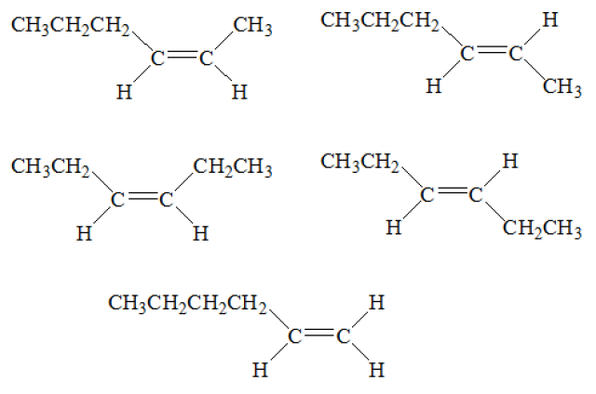
ii
i
iv
iii

- How many moles of oxygen would be consumed by the complete combustion of 1 mole of Compound (i)?
- 1 mole
- 3 moles
- 9 moles
- 12 moles

- Br₂ was reacted with each of the compounds. Which reactants would produce the same products as a result of the reaction?
- i and iii
- ii and iii
- iii and iv
- ii and iv

- An aqueous solution of butanoic acid can react with:
- magnesium to produce a solution of magnesium butanoate and hydrogen gas
- solid potassium carbonate to produce a solution of potassium butanoate, carbon dioxide gas and water
- sodium hydroxide solution to produce a solution of sodium butanoate and water
- acidified propan-1-ol to produce butyl propanoate and water
Which of the above statements is true?
- I and IV only
- II and IV only
- I, II and III only
- I, II, III and IV

Section Two: Short Answer

Question 11 (3 marks)

  - Define the term ‘functional group’. (1 mark)

Group of atoms that are responsible for the characteristic chemical reactions of a particular compound. (1)
(should show the relationship to chemical properties)

  - Complete the table by naming the functional groups labelled A-D. (2 marks)

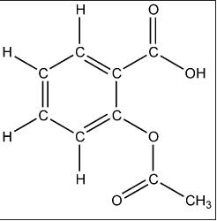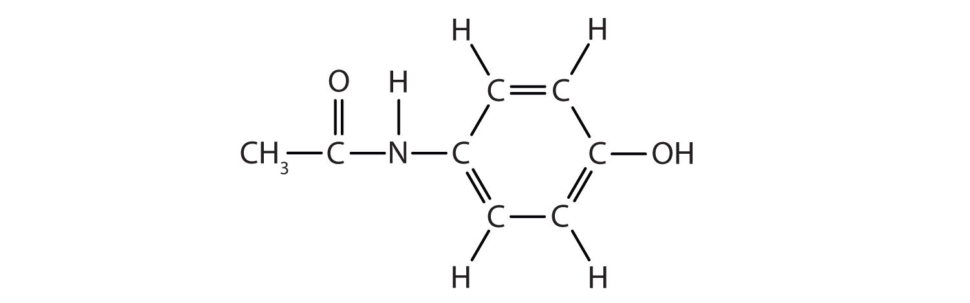
(A)
(B)
(C)
(D)
Label on diagram | Name of functional group
A | Carboxylic acid (0.5)
B | Ester (0.5)
C | Amide (0.5)
D | Alcohol (0.5)

Question12 (6 marks)
Complete the following table.
Name | Structural formula (showing all atoms)
cis-but-2-ene
methylpropanal  (accept 2-methylpropanal | 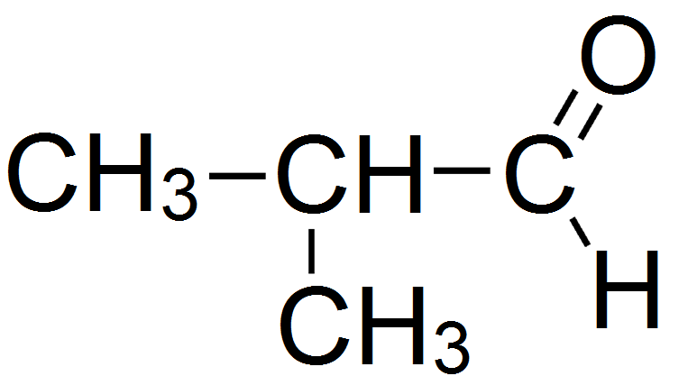
4-methylpentan-2-ol
butyl ethanoate | 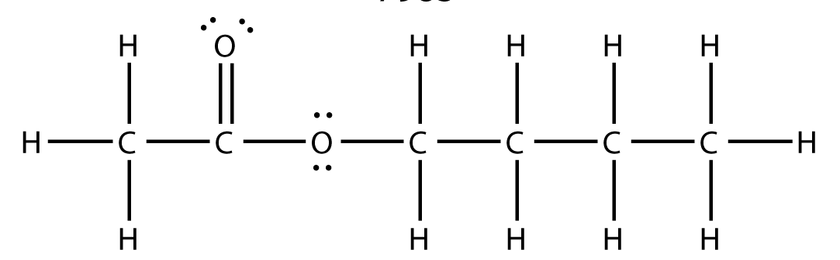
2-iodobutanoic acid
4-chloro, 3 methyl pentanoic acid

Question 13 (4 marks)
Use structural formulae to show the organic product(s) of the following reactions. Show all bonds around functional groups clearly. e.g. write 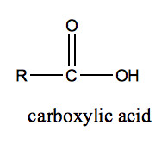 instead of -COOH.
If no reaction occurs, state this clearly.
Reactants | Structure of organic product(s)
CH₃CH=CHCH₃ + H₂O$\underset{→}{{\text{H}}^{\text{+}}\text{ catalyst}}$

H⁺
OH
CH₃CHCH₂CH₂CH₃ + KMnO₄
CH₃OH + CH₃COOH | 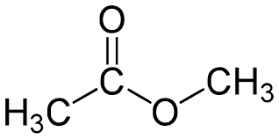
CH₂=CHCHO + Cℓ₂(g) | 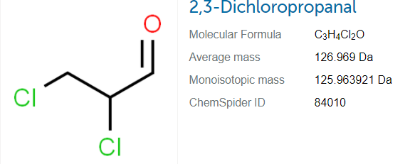

Question 14 (9 marks)
Propane, propanal and propanoic acid all contain the same number of carbon atoms but display different physical properties. Their boiling points are given in the table below.
Organic compound | Boiling point (°C)
Propane | -42
Propanal | 49
propanoic acid | 141

  - Account for the difference in boiling points of the three compounds.
(5 marks)
- The difference in boiling points is due to differences in strength of intermolecular forces (1)

- Propane has weak dispersion forces between molecules (1) and these are weaker than dipole-dipole forces in propanal therefore propane has lowest boiling point (1)

- Propanoic acid has hydrogen bonding as their predominant intermolecular force (1)
Therefore it has higher boiling point than propanal because greater amounts of energy needed to break the bonds, resulting in highest boiling point (1)

  - Which of these compounds would be expected to be most soluble in water? Give reasons for your choice. (2 marks)

- Propanoic acid is most soluble in water (1)

- Due to the presence of the –OH and C= O groups ( strong polar carboxyl group) propanoic acid can form strong hydrogen bonds with water (1)

  - Would the expected boiling point of butan-1-ol be greater or less than 92.7 °C (the boiling point of propan-1-ol)? Give reasons.
(2 marks)
- Butan-1-ol has greater boiling point than propan-1-ol (1)
- As the non-polar carbon chain length increases, the weak intermolecular forces (dispersion) holding the chains together becomes increasingly significant, so more energy needed to separate the molecules. (1)

Question 15 (10 marks)
Two different compounds A and B are isomers with the molecular formula C₃H₈O.
A and B undergo a series of reactions as shown below.
A
C₃H₈O
C
C₃H₆O₂
D
C₃H₅O₂Na
acidified K₂Cr₂O₇
added dropwise
1. NaOH added
2. solution evaporated
B
C₃H₈O
E
C₃H₆O
acidified K₂Cr₂O₇
added dropwise

(a) Give the structural formulas for C and E. (2 marks)

Structural formula of C | Structural formula of E

(b)How is compound A different from compound B? (1 mark)

Compound B has hydroxyl (OH) group attached to centre carbon instead of terminal carbon
OR
Compound B is a secondary alcohol while Compound A is a primary alcohol
OR
Compound B is propan-2-ol. Compound A is propan-1-ol.

(c)Describe the colour change observed when acidified K₂Cr₂O₇ is added to A. (1 mark)

Orange solution (½ mark) turns green (½ mark)

  - Write half-equations to show the reaction that forms compound C. Label which half-equation is oxidation and which half-equation is reduction. (4 marks)

Oxidation  …………………..  half-equation | C₃H₈O + H₂O → C₃H₆O₂ + 4 H⁺ + 4 e–
Reduction ………………..  half-equation | Cr₂O₇²⁻ + 14 H⁺ + 6 e⁻ → 2 Cr³⁺ + 7 H₂O

- 2 marks for C₃H₈O half-equation (give 1 mark for single mistake with follow through)
- 1 mark for Cr₂O₇²⁻ half-equation (copied from data sheet)
- 1 mark for having oxidation and reduction half equations in the correct boxes

B and C can react together in the presence of a small amount of concentrated sulfuric acid to produce F.

  - Name the type of reaction that occurs between B and C to from F. (1 mark)

Esterification OR Condensation

  - Draw the structural formula of F. (1 mark)

Question 16 (8 marks)
Three different organic compounds were each tested with two reagents:
- acidified sodium permanganate solution and
- acidified propanoic acid
Each organic compound has a molecular formula containing five carbon atoms, one oxygen atom and a number of hydrogen atoms.
The observations made are summarised in the following table.
Unknown organic compound | Reagent added
 | acidified  sodium permanganate solution | acidified  propanoic acid
1 | no observable change | fruity smell
2 | purple solution decolourises | non observable change
3 | non observable change | non observable change

- Complete the table below, identifying the:
- functional group responsible for the observations made
- organic compound, by drawing its structural formula or giving its name.
(6 marks)
Unknown organic compound | Functional group | Structural formula or name of the organic compound
1 | alcohol | Tertiary alcohol  (2 methyl butan-2-ol)
2 | aldehyde | Pentanal
3 | ketone | Pentan-2-one

- Draw the structural formula, showing all atoms of the organic product of the reactions of Compound 1 and Compound 2.
(1 mark)
- Organic Compound 1 with the acidified propanoic acid

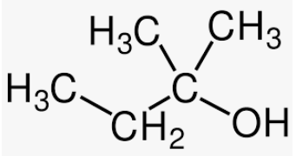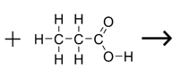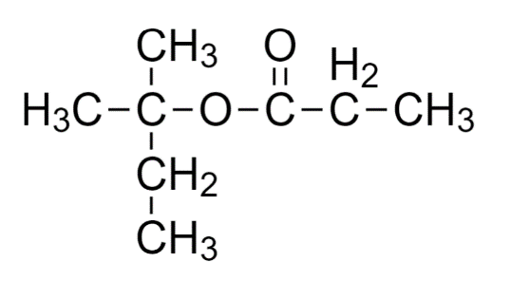

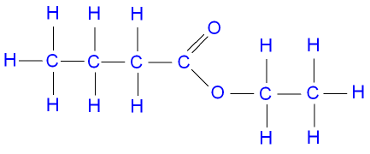






(1 mark)

- Organic Compound 2 with the acidified sodium permanganate solution
`
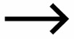
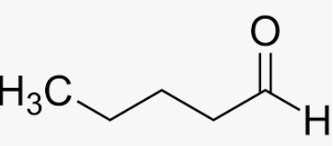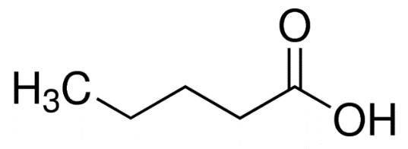
H⁺/MnO₄⁻

SPARE PAGE

